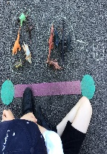
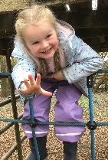
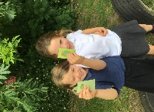
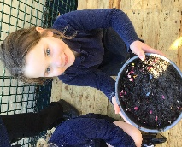
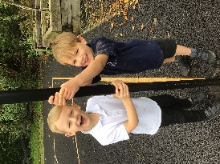

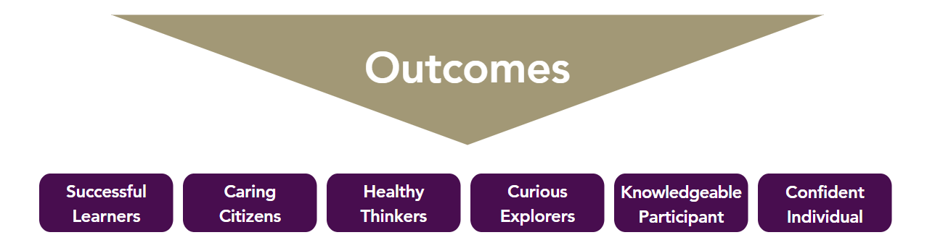
Community Partnerships
Village Treasure Map – Autumn 1
Aspiration Afternoon – Spring 1
Village scarecrow building – Summer 2

Cross Trust and other school events
Christmas Fayre- Autumn 2
Sports Day- Summer 2
ACE Olympics – Summer 2

Church and mission community Projects
Harvest festival – Lord’s Larder collection – Autumn 1
Christingle and Carol Service – Autumn 2
Easter Service – Spring 1
Clypping Service – Summer 1

Character Education Opportunities
Nativity- Autumn 2
World Book Day events – Spring 2
VE Day celebrations – Summer 1
Weekly Values certificates

Leadership
Meet and Greet Ambassadors

Personal Development and Enrichment Opportunities Year R/1
Keeping Safe

Road Safety Talk – Spring 1
MHST workshops

Visitors and Expert Leads
Bread making workshop with Mr Burns- Spring 1
Viking workshop – Spring 1
Forest School – Termly
‘Open the Book’ - Weekly

Visits and Trips
Village Walks - Autumn 1
Geography fieldwork to Street – Summer 2

