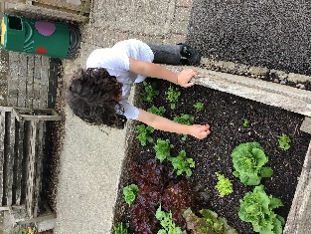
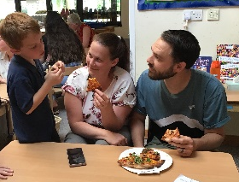
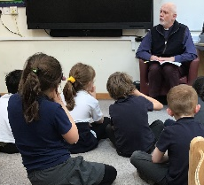

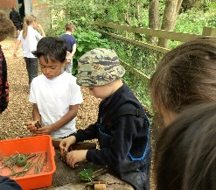
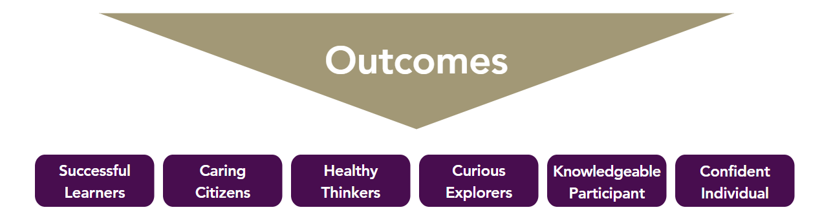
Church and mission community Projects
Rev Chris visits – throughout the year
Harvest Festival – Donations to the Lord’s Larder Food Bank– Autumn 1
Christingle Service at Church – Autumn 2
Carol Service – Autumn 2
Easter Service – Summer 1
Clypping Service – Summer 1

Community Partnerships
Creating a scarecrow for the village scarecrow trail-Summer 2
Entries for the village show-Summer 2
Camelot Pizzeria – Summer 1
Christmas Fayre – Autumn 2

Cross Trust and other school events
Easter Bonnet Parade – Spring 1
ACE Olympics – Summer 2
Sports Day- Summer 2

Character Education Opportunities
Values certificates - Weekly
Nativity – Autumn 2
World Book Day Events – Spring 2
VE Day Celebrations – Summer 1

Leadership
Meet and Greet Ambassadors – All year

Personal Development and Enrichment Opportunities Year
Keeping Safe
MHST Workshops – Summer 2

Road Safety Talk – Spring 1

Visitors and Expert Leads
Forest School – Half termly
Viking Workshop – Spring 1
Open the Book Bible Stories - Weekly

Visits and Trips
Cheddar Caves - Spring 1
Roman Baths - Summer 2

