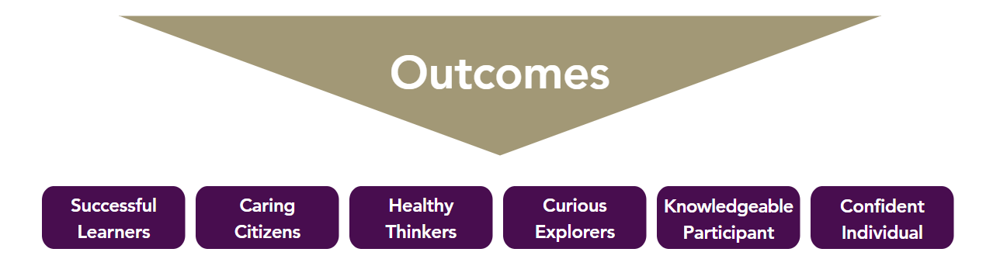
Visits and Trips
Bristol Hindu Temple and Bristol Cathedral – Autumn 2
Westonzoyland Battle of Sedgemoor Centre and battle site – Spring 1
Christmas Unwrapped at Street Baptist Church – Autumn 2
Moving Up Service at Wells Cathedral – Summer 2

Community Partnerships
V.E. Day 80 outcome – stories shared at a work exhibition attended by the village community – Spring 2
Helping the PTA deliver a cream tea morning for the village community – Spring 1
Entries for the village show – Summer 2
Food DT outcome – inviting parents in for a food fair – Spring 2

Cross Trust and other school events
ACE Olympics – Summer 2
Easter Bonnet Parade – Spring 1
Sports Day – Summer 2

Church and mission community Projects
Rev. Chris class and whole school visits – throughout the year
Harvest Festival, including donations to the Lord’s Larder Food Bank – Autumn 1
Christingle service – Autumn 2
Easter service – Autumn 3
Year 6 leavers’ service – Summer 2

Character Education Opportunities
Preparing and performing the end of year production – Summer 2
Values Certificates – weekly
Writing and delivering a speech to team members outlining their promise as team captain – Autumn 1
Evolution and Inheritance outcome – preparing and delivering a power point to years 2 and 3 – Spring 1

Leadership
Leading year 6 collective worship – weekly
Running the school council – half termly
Team captains and vice captains - daily

Personal Development and Enrichment Opportunities Year 6
Keeping Safe
Healthy eating – Autumn 2
Exercise education on maintain a healthy mind and body – Autumn 2
Online safety – occurring throughout the year
Relationships and SE – Summer 2

Visitors and Expert Leads
Forest school – half termly
Viking workshop – Spring 1
Community member weekly visits to share stories from VE day 1945 – Spring 1 and 2
Open the Book - weekly

