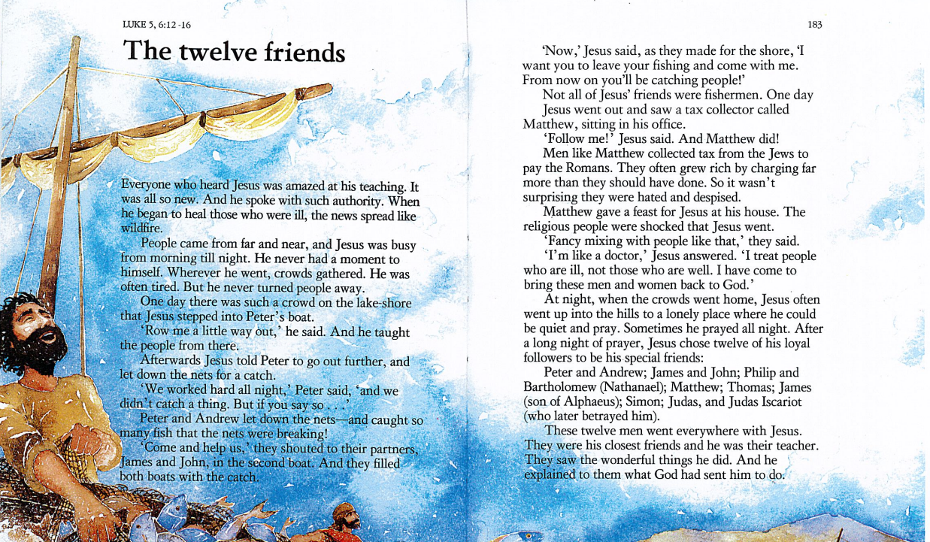
Source: The Lion’s Children’s Bible

